**Modular robotic platform for modern greenhouses**

* **Executive Summary**

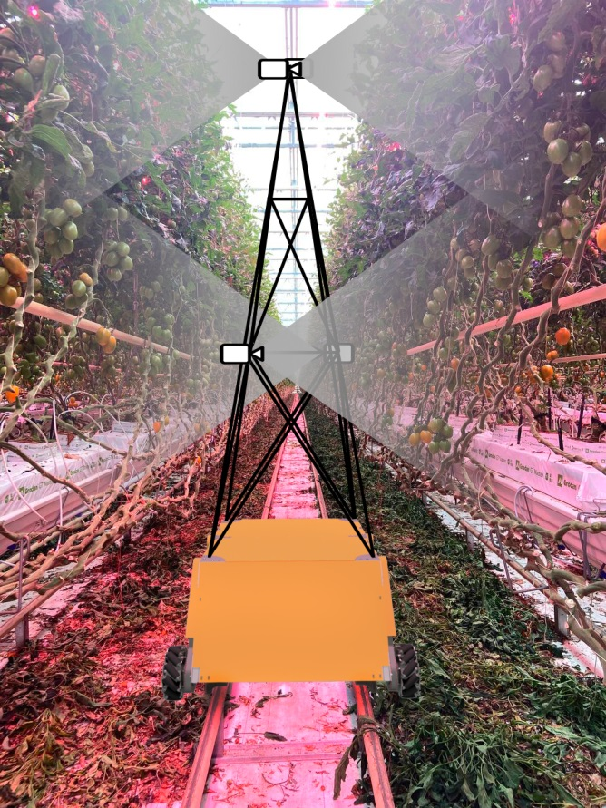Russia has shown great success in import-substitution of agriculture since the first round of sanctions in 2014-2015. One of these success is the creation of a one of the Europe’s largest tomato greenhouse complexes of 105 ha by Agroinvest Group, a resident of Kaluga Special Economic Zone. The greenhouses are equipped with modern technological solutions for effective production of cultures shipped regularly to federal retailers under the “Moyo Leto” brand. The new round of unprecedented sanctions of 2022 put extreme challenges to technological development of the greenhouse complex, and in general to the domestic agriculture. Shortly prior to the dramatic new circumstances, Agroinvest Group was planning to implement a robotized crop monitoring system. As the basis, the company group was planning to make use of Berg Hortimotive robotic platforms, then not purchased, but merely utilized on a subscription basis. The reality has changed and this option is no longer available. As of now, no direct alternative is available on the market that could be customized so as to fulfill the Agroinvest Group goals.

Figure 1. A concept of a greenhouse robot with mast with cameras for crop monitoring

The key goal here is a regular monitoring of the cultivated crop condition. It is important to timely detect plant diseases, as well as to predict crop yield. The use of manual labor to perform these activities involves a lot of time, effort and cost. Besides, human workers may be subjective in their assessment of the crops.

This project offers the design and implementation, with subsequent comissioning at the Agroinvest Group greenhouse complex, of a robotic platform with integrated computer vision systems and on--board software for crop assessment. The robot will be able to drive on solid pavements and on rails, typically found in inbetween-row space in greenhouse. The platform is universal with the option to install various equipment on it, such as an optical plant monitoring system, a system for processing/removing damaged plants, etc.

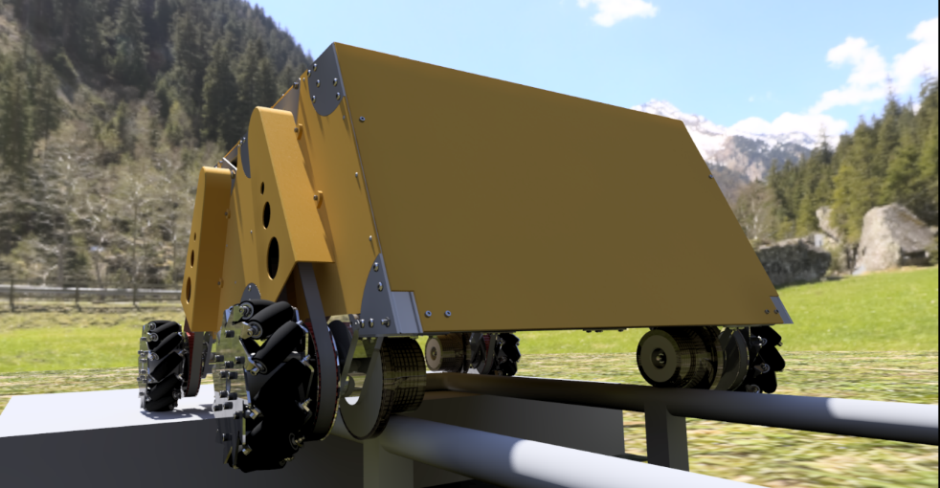The modularity of the platform allows the chassis design to be scaled up to increase payload capacity if needed. Modern greenhouses have flat floors and are equipped with pipe rails designed for the movement of wheeled carts. This sets wheeled platforms in favor compared to flying or walking robots. Furthermore, modern greenhouses are so large that installation of fixed chambers and / or plant processing modules is rather non-profitable. According to data provided by Agroinvest Group, their greenhouses are about 400 meters long and 260 meters wide. The number of rail tracks exceeds 500 pieces. The robot will be able to automatically move along the rail tracks between the rows of plants and perform the necessary work.

Figure 2. A close-up of the robot with parts of the drive train visible

* **Opportunity**

Unlike conventional production lines, agricultural production is connected with a high uncertainty on the crop yield. Each plant has its own fertility. Fertilizers may help equalize this somewhat, but the necessity of monitoring is still inevitable. Crop yield prediction errors lead to economic losses. When fruits are harvested in excess of the predicted amount, part of the production has to be disposed, resulting in profit losses. When fruits are harvested below the predicted quantity, a violation of the supply contract occurs. This is connected with losses as well. Timely detection and counting of ripening fruits, flowers and ovaries will make it possible to predict the quantity of products with high accuracy for the correct preparation of supply contracts. This will reduce losses and improve product quality by optimizing the frequency of harvesting. As mentioned in the previous section, this process is tedious. Technologies, like the one by Berg Hortimotive Ltd., exist that help automate the described tasks. The access to these technologies is currently either non-available or connected with high risks. The opportunity of the claimed STRIP project is the creation of a domestic technology that could not only be employed by Agroinvest Group, but any domestic agricultural producer, which utilizes greenhouse production. Furthermore, friendly countries will likely become our customers as well.

* **Proposed Approach or Product**

The basis of the robot structure is a space frame made of aluminum pipes, sheathed with aluminum composite panels. Bearing supports with rail wheels and mecanum wheels are installed under the frame. It is possible to change the chassis configuration by changing the length of the frame pipes or by changing the number of wheel supports and servomotors. The width of the chassis remains unchanged, as it is tied to the gauge of the rails.

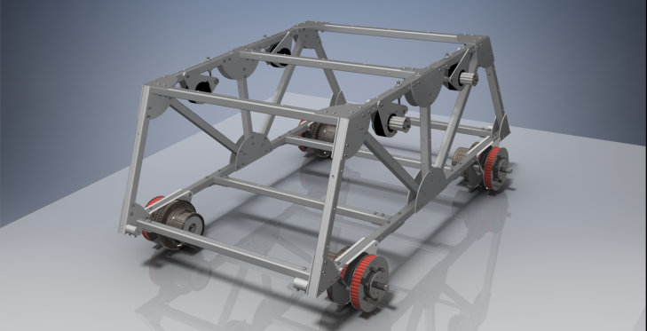

Figure 3. Chassis frame of the proposed greenhouse robot. Drives are seen beneath the frame.

The omnidirectional mecanum wheels allow the chassis to move forward and backward, right and left, and turn in place. Rail wheels are mounted on one shaft with an omnidirectional wheel, allowing the robot to move evenly along the pipe rails. Rotation to the wheels is transmitted from servomotors through a synchronous toothed belt. The use of a belt drive helps to protect the servomotors from shock loads.

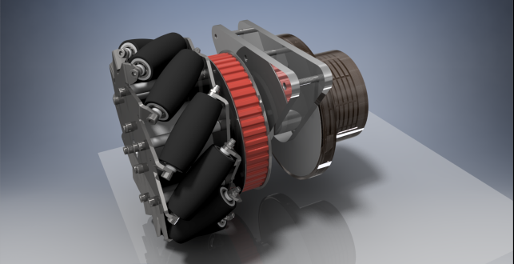

Figure 4. A mecanum omnidirectional wheel that constitutes the core of the propelling unit.

The interior space of the large volume robot allows you to install a large number of additional equipment. Figure 5 shows the location of the main components of the robot, such as batteries, inverter voltage converter and charger. High energy density LiNCA batteries provide up to 12 hours of battery life and minimal weight. The inverter provides high-quality power supply to the on-board computer and control systems. The charger is equipped with an RS-485 interface that allows on-board computer to control the charging process.

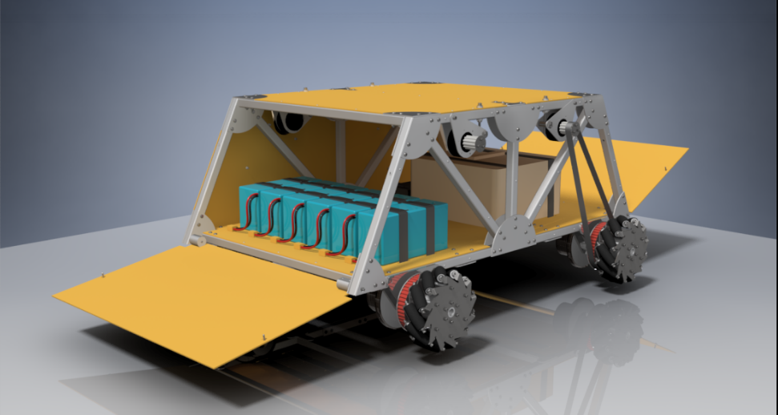

Figure 5. Batteries installed in the inside of the root frame.

* **Commercialization and Competitors**

The main competitors are manufacturers of automated smart greenhouse carts, such as the ones by Berg Hortimotive Ltd., and arugga Ltd., who ship highly specialized solutions. We are going to offer a versatile platform that can be adapted to a variety of tasks and at the same time be more energy efficient compared to the existing products. The potential sale markets are large agro-industrial enterprises which employ greenhouse crop production. The prospective financing sources are the STRIP and Skoltech startup support along with the Skolkovo. The STRIP funding program is needed to boost the prototype development already started at the AI in dynamic action lab of the Digital Engineering Center. Agroinvest Group expressed their interest in the project, a respective letter is attached. With the developed prototype, we are likely to get financial support from Agroinvest Group to help advance the project to a miniseries production. We also plan to prove a sufficient technology readiness level to apply to state funding in the frame of the Order No. 555 of the Russian Federation Government.

The potential capacity of the greenhouse market for offering robotic platforms in the Russian Federation alone is at least 2,000 ha. Shipment of our products to friendly countries is to be considered as well. After the first year, we expect a minimal viable product, and after a second year -- a commercialization-ready prototype. The market value comes from the savings on human labor, primarily. The services that support the exploitation of the robot by the end user are maintenance, personnel training, algorithms tuning in new environments.

Concluding, we need a support to purchase additional equipment, such as materials, extra cameras and actuators, hire staff, since we are currently a small group of people actively involved in educational and academic activities as well. We need to strengthen the core personnel dedicated to the project, whence the STRIP application.

* **Deliverables**

***Plan***

1. First year:
   1. Automation:
      1. Automatic orientation inside the greenhouse;
      2. Finding pipe rails. Entry and exit from the rails;
      3. Automation of the battery charging process;
   2. Integration:
      1. Computer vision solutions to detect obstacles, moving objects (e.g., human workers, vehicles);
      2. User interface.
2. Second year:
   1. Crop monitoring algorithms with implementation;
   2. Testing and calibration at the Agroinvest Group greenhouse complex;
   3. Commercialization arrangements.

***Deliverables***

1. First year:
   1. Code for navigation, orientation, obstacle avoidance;
   2. Code for integration of computer vision, motion system and charge control system;
   3. A minimal viable product – the robot with the necessary functionality to demonstrate automatic movement in the lab.
2. Second year:
   1. Code for plant condition monitoring system;
   2. Field data, reports;
   3. Prototype ready for commercialization.

The first year is associated with the creation of a working prototype of the chassis and the automatic movement and recharging system. This is due to the fact that in order to create a system for monitoring the state of plants, it is necessary to ensure the automatic movement of the robot along the rows of plants and its movement from a row to a row.

* **Team and Collaborations**

***Team***

***Project leader***: Pavel Osinenko (PhD, Assistant Professor, DEC) will carry out project supervision, work out detailed schedule, track the key steps and deliverables.

***Staff***:

1. ***Ilya Osokin*** is currently a PhD student under the supervision of P. Osinenko. He develops robot control and navigation algorithms using computer vision;
2. ***Mikhail Patrikeev*** is currently a PSA engineer, but planning to be a full-time engineer of the team. He develops the design of the wheeled chassis and is engaged in the production and assembly of the experimental prototype.
3. ***Alexey Sokolov*** is currently an engineer at DEC, core team, being redirected to the current project

* ***Collaborators***

Our primary collaborator and customer is Agroinvest Group, a letter of support is attached. Inside Skoltech we are collaborating with the AI technology Center. The latter concentrate on neural network training for crop disease recognition. We are planning to apply for a state funding together in the frame of the Order No. 555 of the Russian Federation Government.

* **Resources and Budget**

For the 5 Mio. RUB over the two years, we are planning to hire a new engineer at a standard Skoltech rate and purchase additional equipment and materials necessary for the manufacture of the second prototype, for which, we presume, a total of 1 Mio. RUB will be sufficient (the first prototype is currently under production).

